USER MANUAL

Dreyer Morkel

DV2011-0590



TABLE OF CONTENTS

1. Administrator functions
   1. How to add a new collection 3
   2. How to update an existing collection 8
   3. How to add a new product 14
   4. How to edit an existing product 21
   5. How to view sales reports 29
2. Customer functions
   1. How to view products in a collection 32
   2. How to search for certain products 34
   3. How to view a product 36
   4. How to log in to an account 39
   5. How to register an account 41
   6. How to add a product to the shopping cart 43
   7. How to remove a product from the shopping cart 48
   8. How to pay for a shopping cart 52
3. Administrator functions
   1. How to add a new collection
      1. Navigate to LOGIN/REGISTER page



* + 1. Log in with administrator account

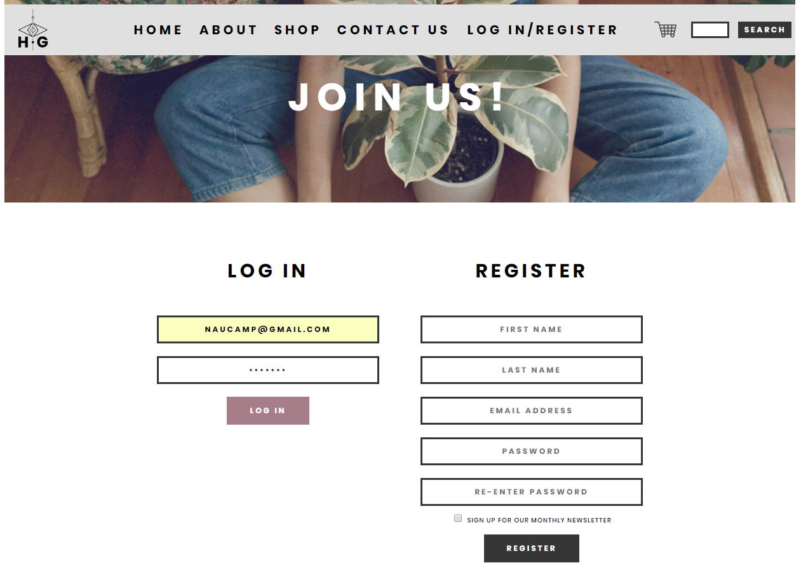

* + 1. Select INSERT COLLECTION

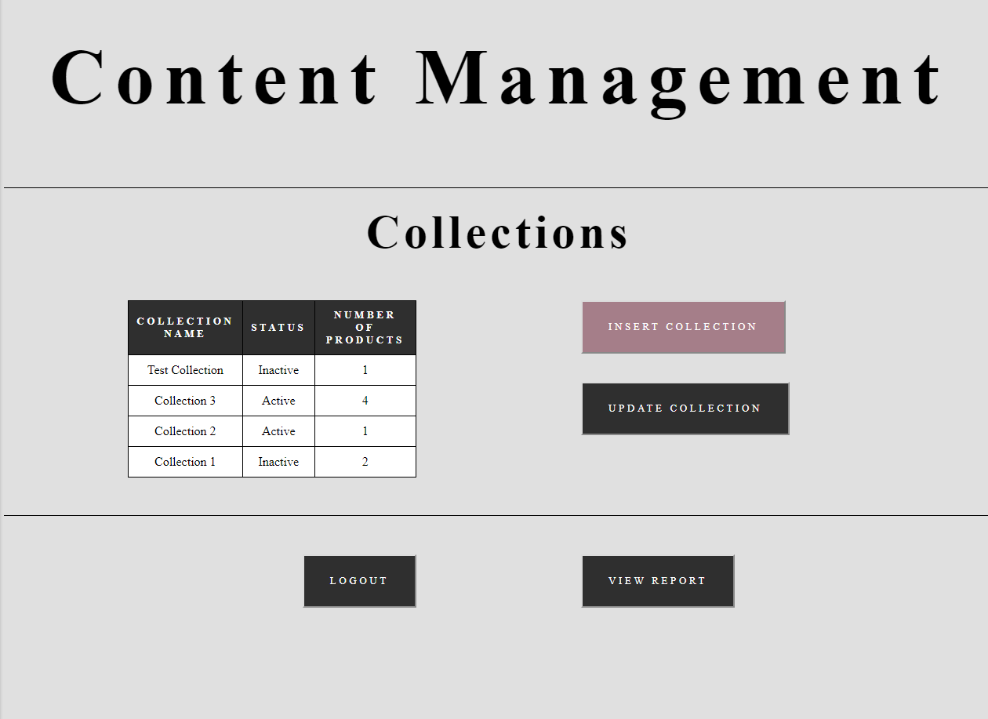

* + 1. Enter collection details

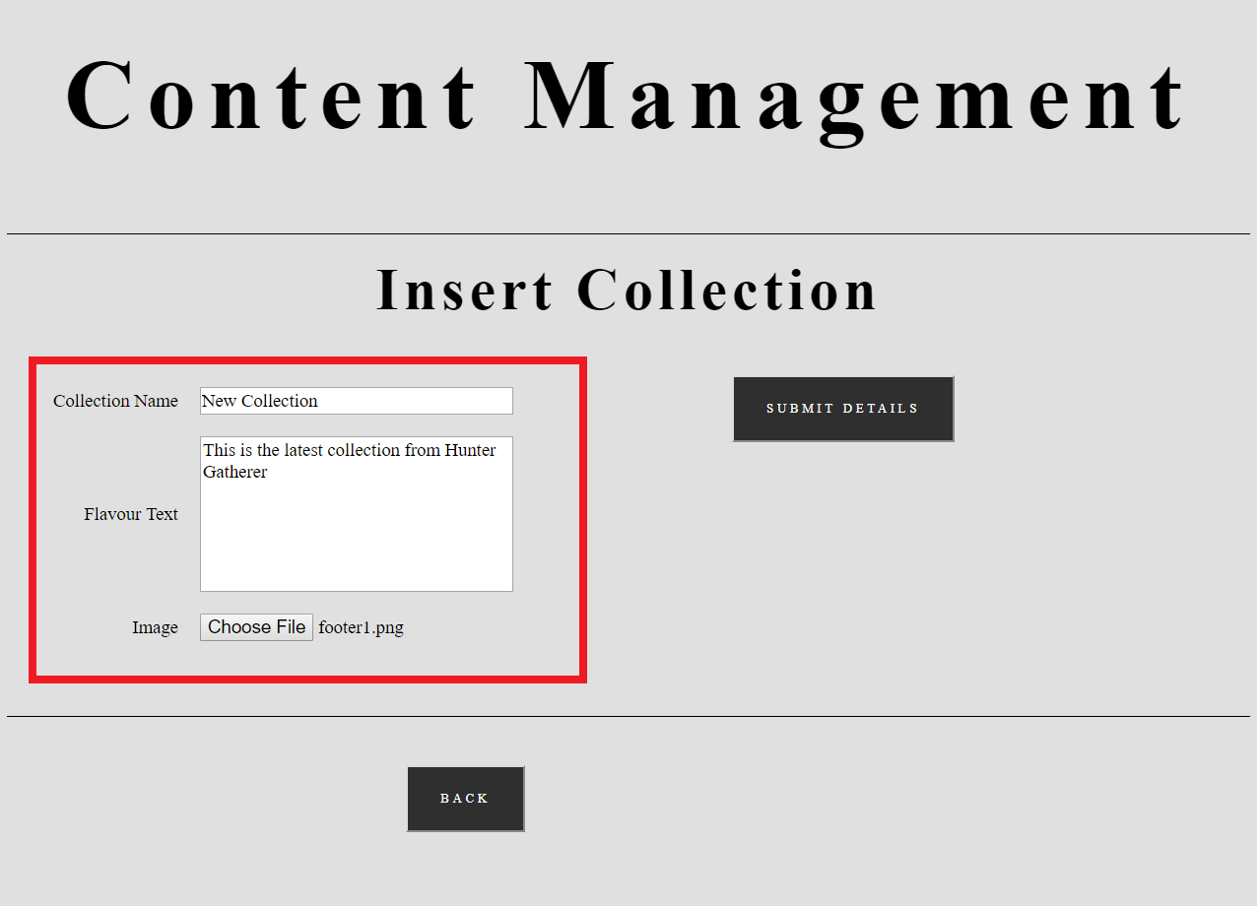

* + 1. Select SUBMIT DETAILS

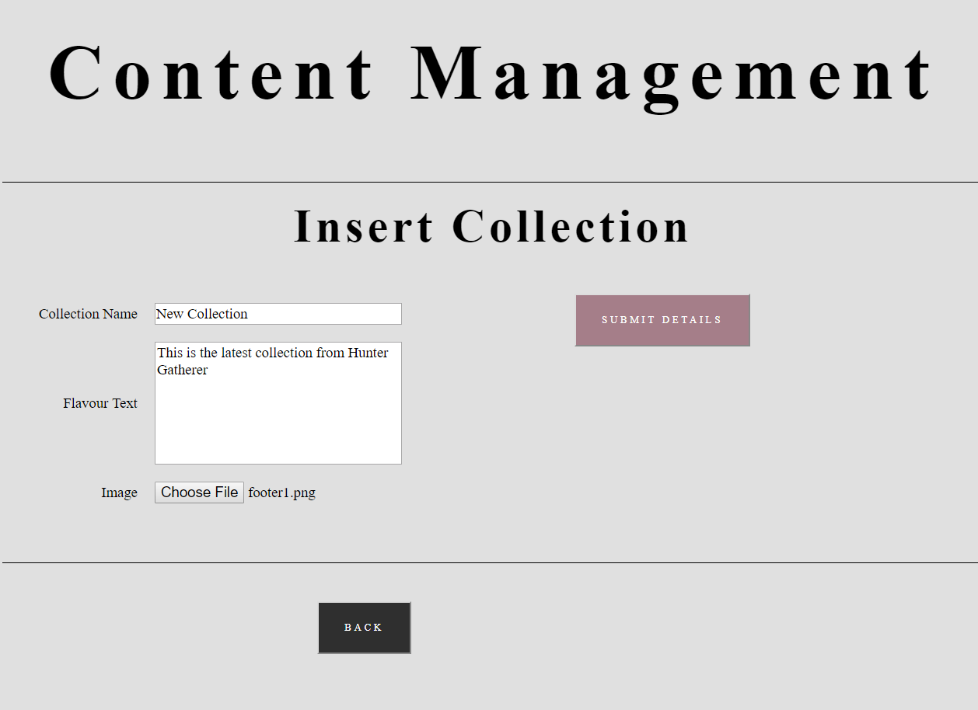

* 1. How to update an existing collection
     1. Navigate to LOGIN/REGISTER page



* + 1. Log in with administrator account



* + 1. Select collection to update

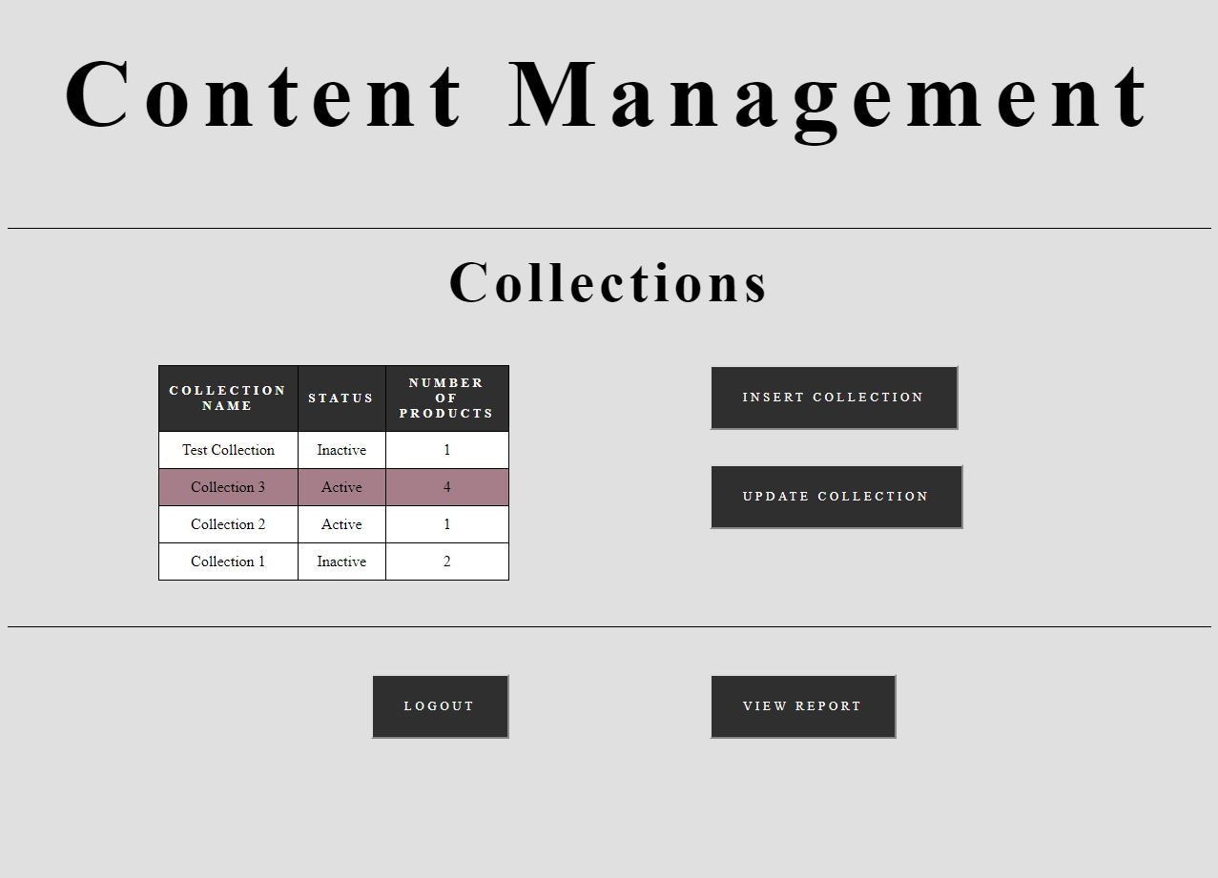

* + 1. Select UPDATE COLLECTION

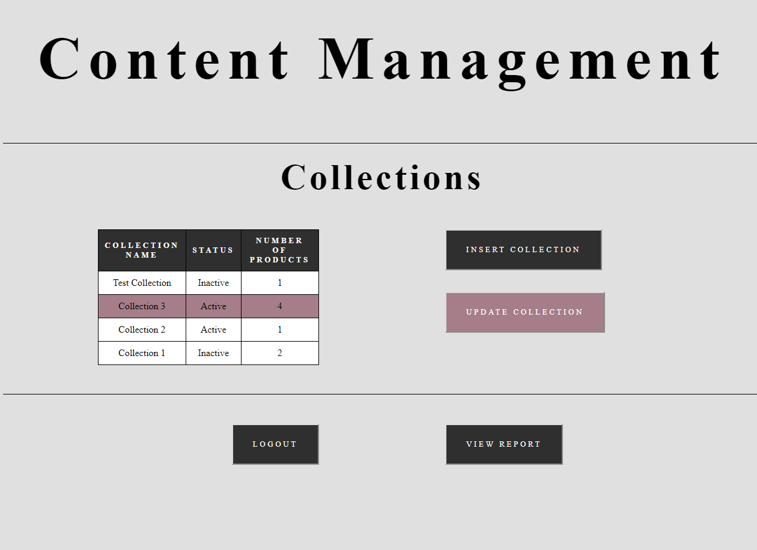

* + 1. Edit collection details

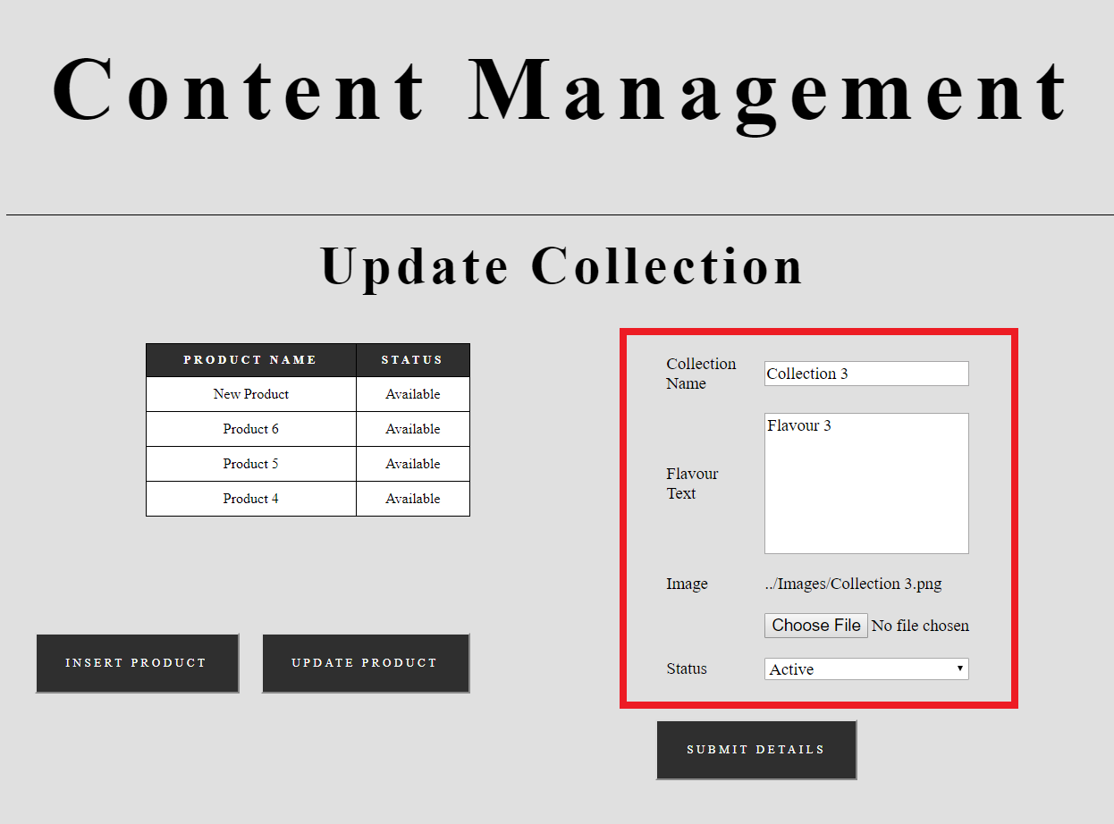

* + 1. Select SUBMIT DETAILS

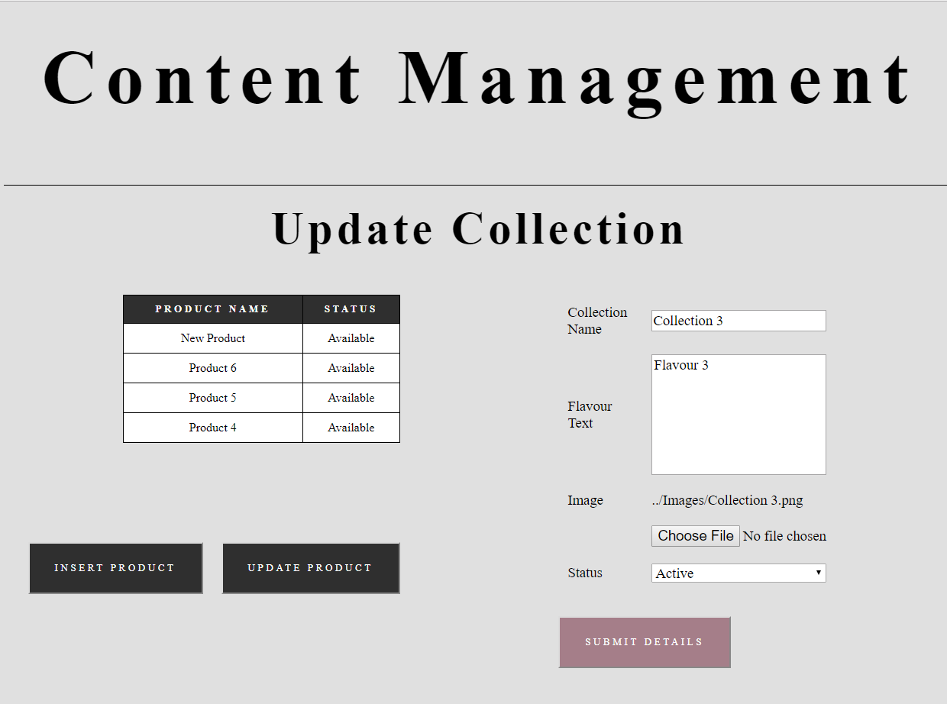

* 1. How to add a new product
     1. Navigate to LOGIN/REGISTER page



* + 1. Log in with administrator account



* + 1. Select collection which product forms part of



* + 1. Select UPDATE COLLECTION



* + 1. Select INSERT PRODUCT

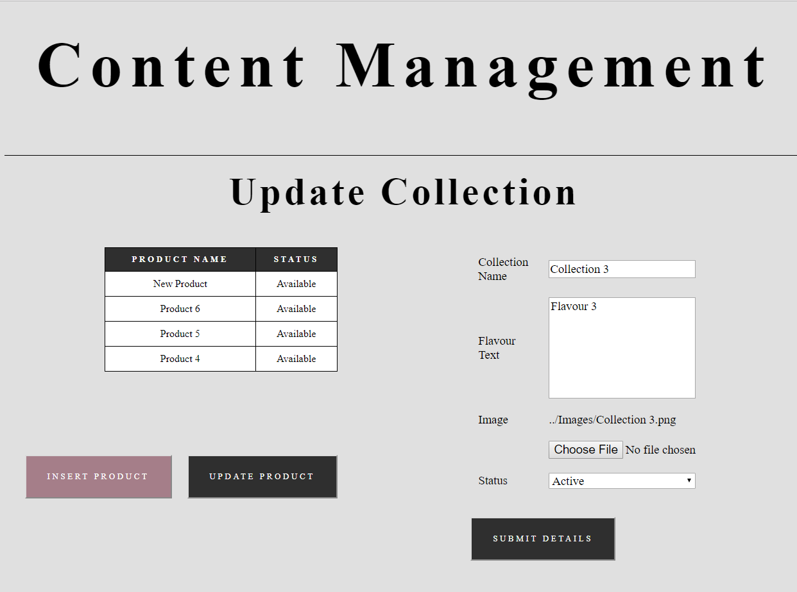

* + 1. Enter product details

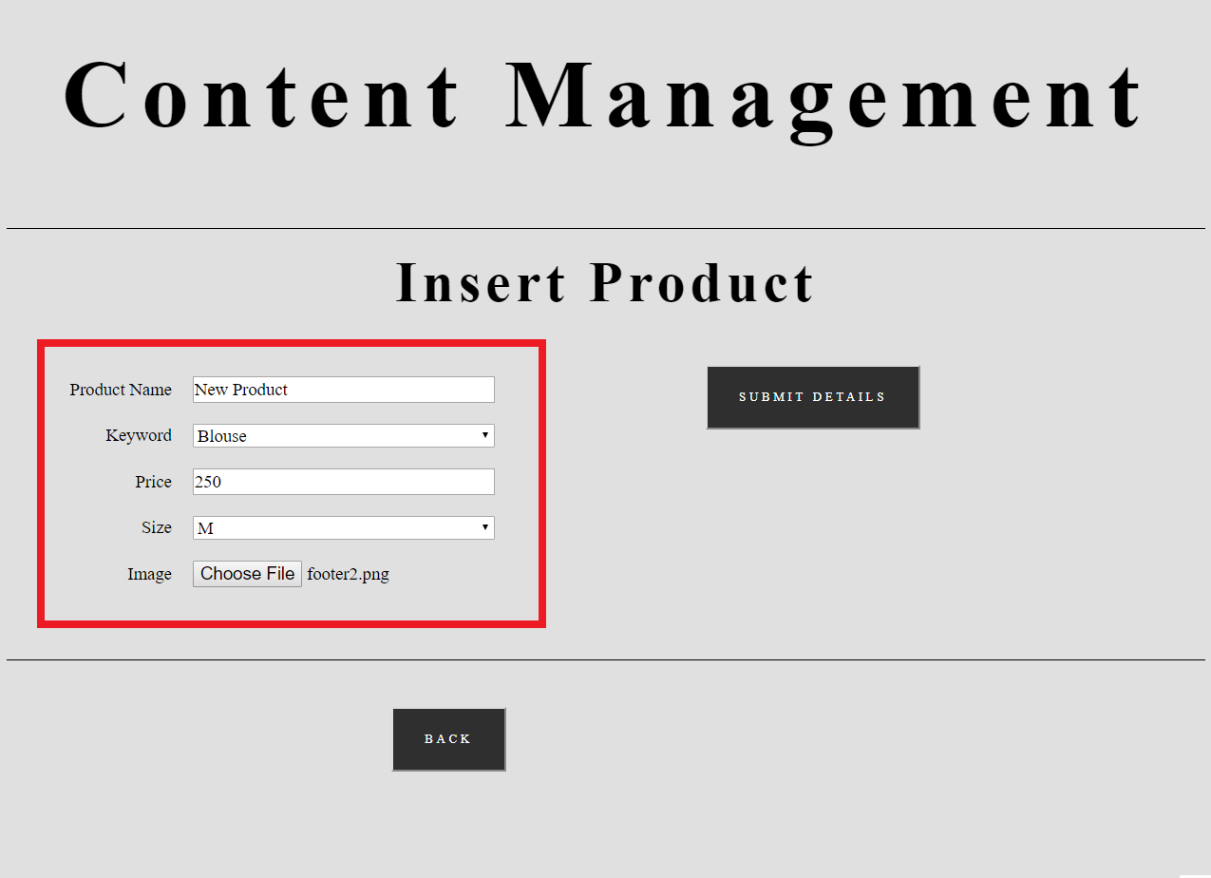

* + 1. Select SUBMIT DETAILS

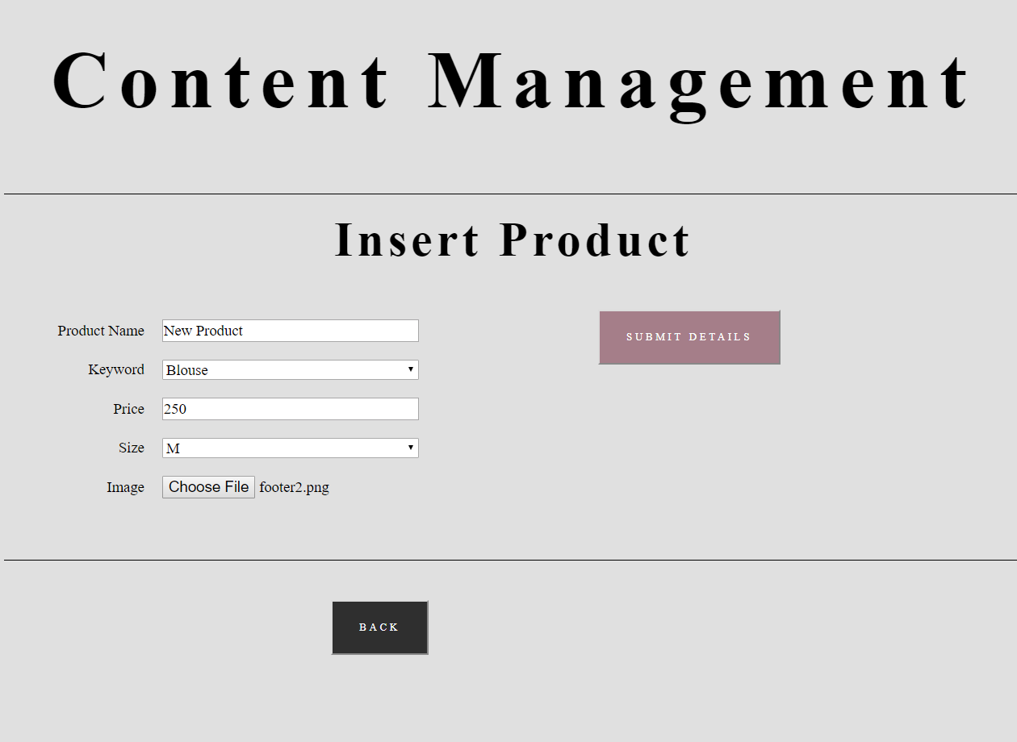

* 1. How to edit an existing product
     1. Navigate to LOGIN/REGISTER page



* + 1. Log in with administrator account



* + 1. Select collection which product forms part of



* + 1. Select UPDATE COLLECTION



* + 1. Select product to update

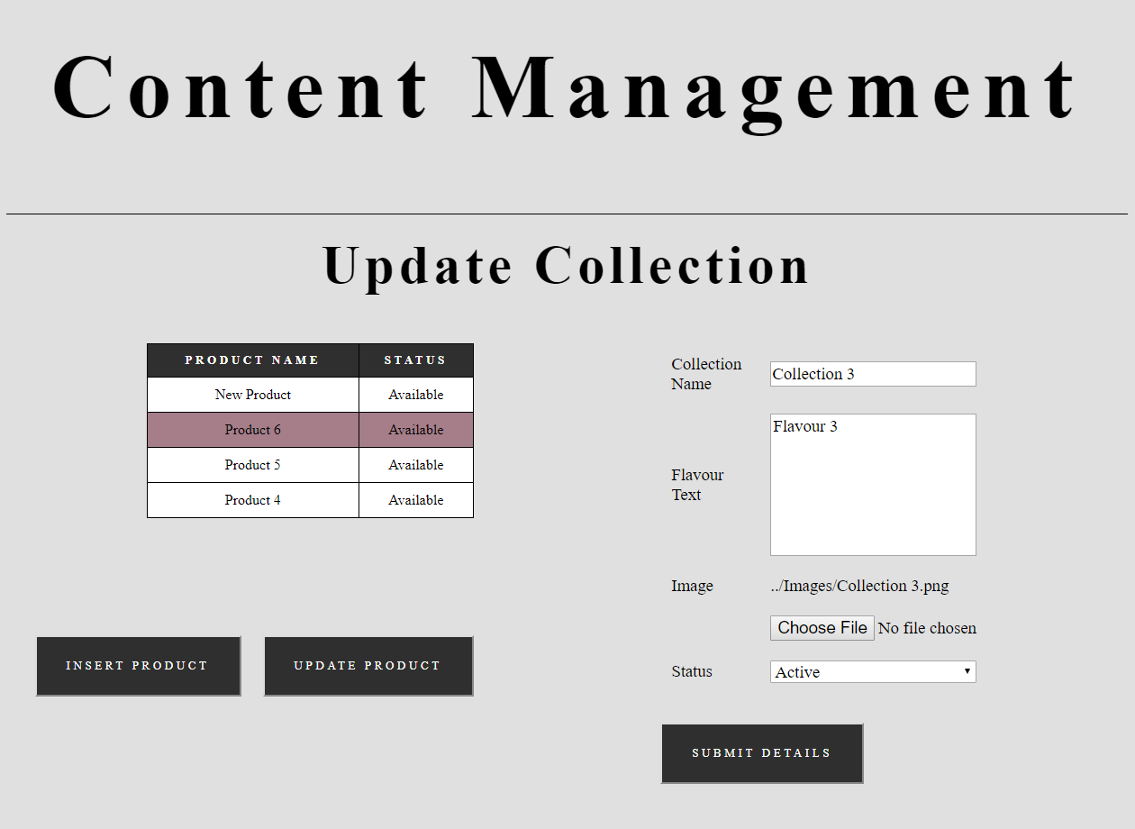

* + 1. Select UPDATE PRODUCT

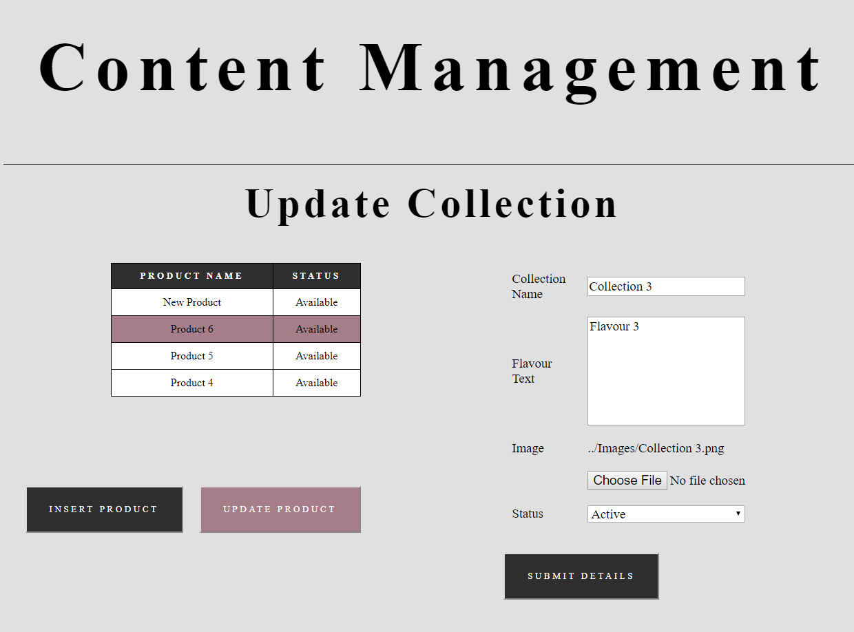

* + 1. Edit product details

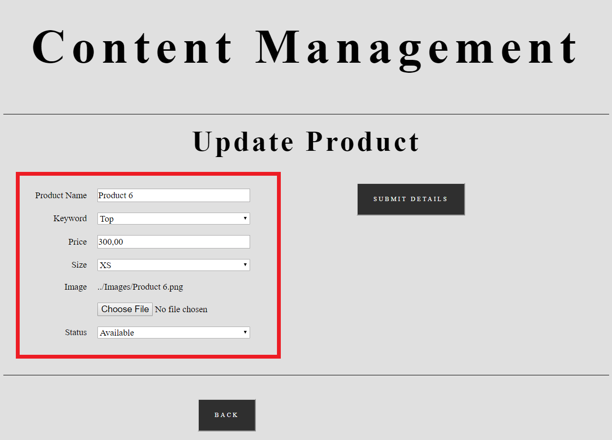

* + 1. Select SUBMIT DETAILS

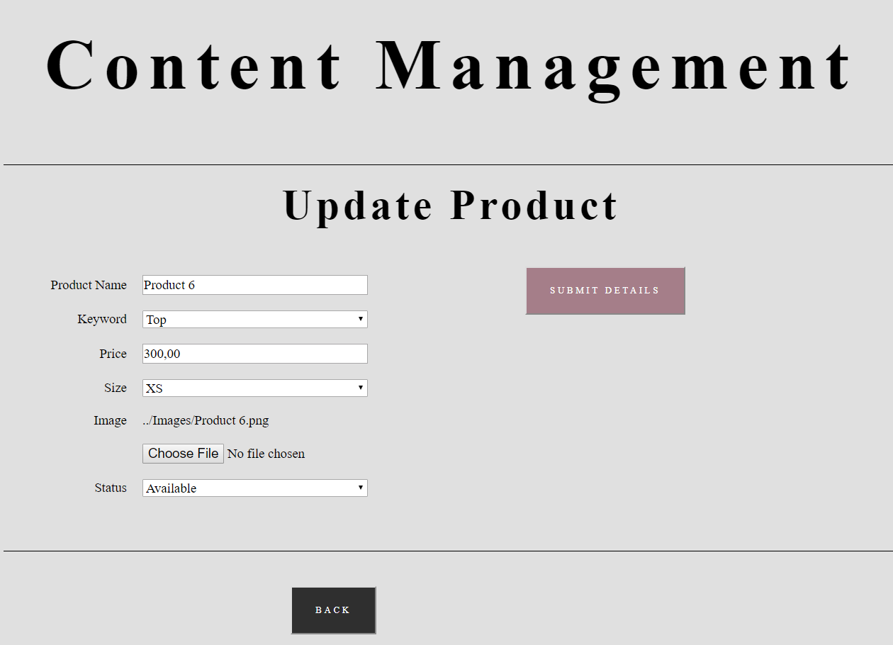

* 1. How to view sales reports
     1. Navigate to LOGIN/REGISTER page



* + 1. Log in with administrator account



* + 1. Select VIEW REPORT

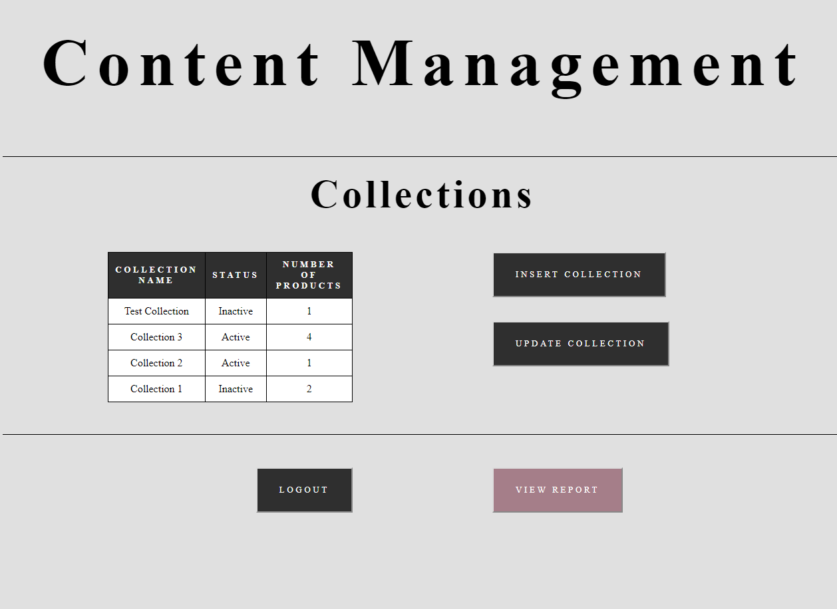

1. Customer functions
   1. How to view products in a collection
      1. Navigate to the SHOP page



* + 1. Scroll to collection and select SHOP NOW

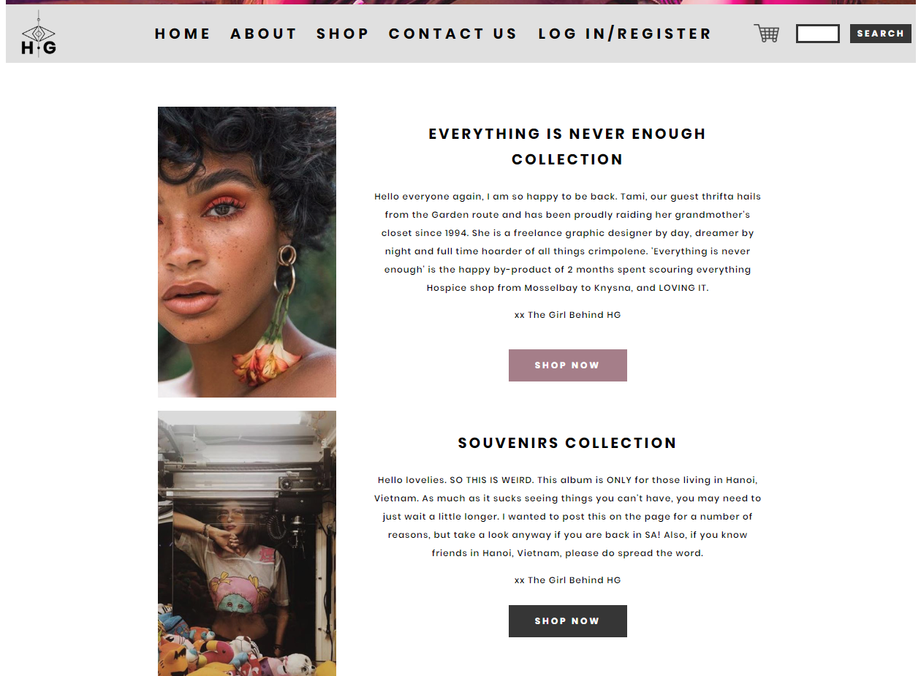

* 1. How to search for certain products
     1. Enter search term into search bar



* + 1. Select SEARCH



* 1. How to view a product
     1. Navigate to the SHOP page



* + 1. Scroll to collection and select SHOP NOW



* + 1. Scroll to product and click on product image

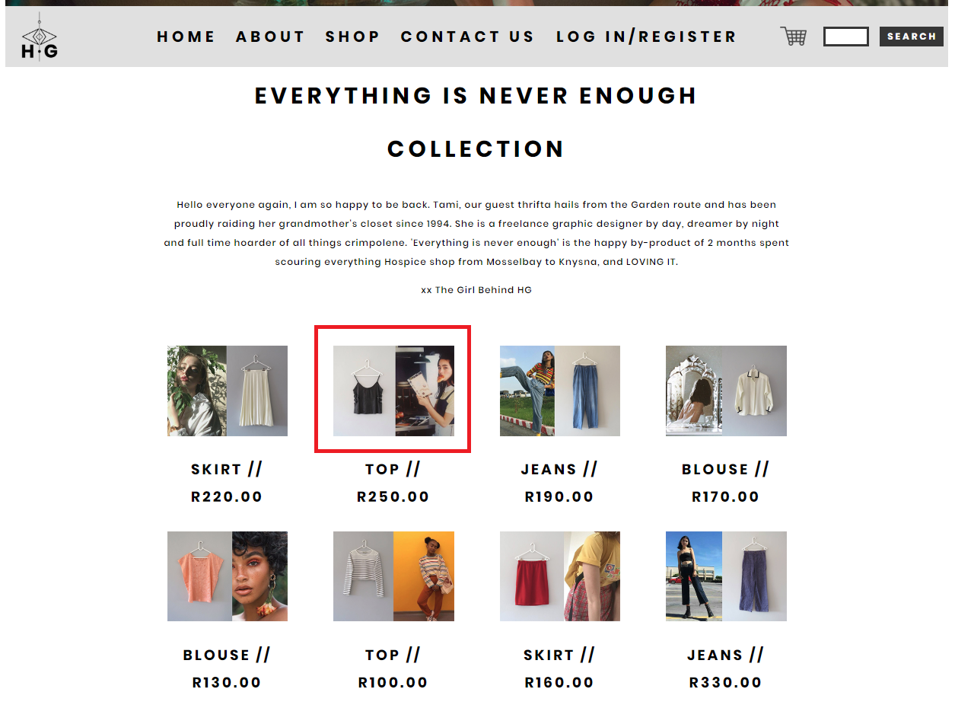

* 1. How to log in to an account
     1. Navigate to the LOG IN / REGISTER page



* + 1. Login with customer account

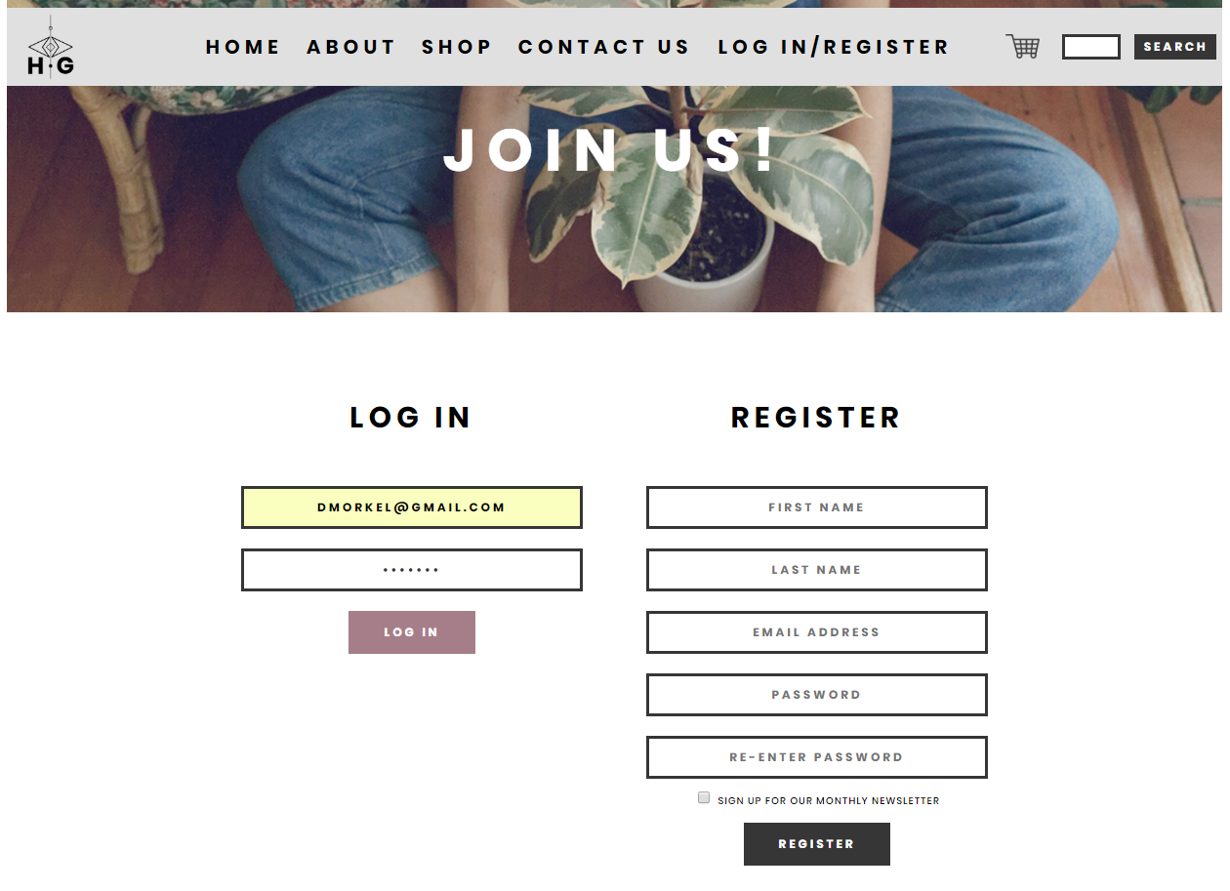

* 1. How to register an account
     1. Navigate to the LOG IN / REGISTER page



* + 1. Register for an customer account

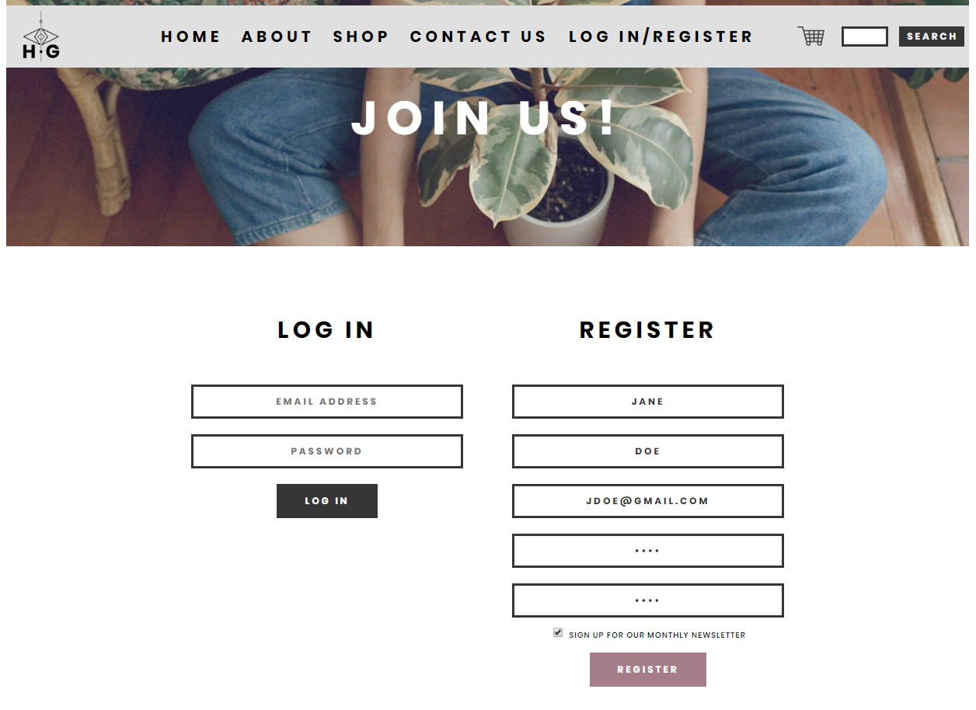

* 1. How to add a product to the shopping cart
     1. Navigate to the LOG IN / REGISTER page



* + 1. Login with customer account



* + 1. Scroll to collection and select SHOP NOW



* + 1. Scroll to product and click on product image



* + 1. Select ADD TO CART

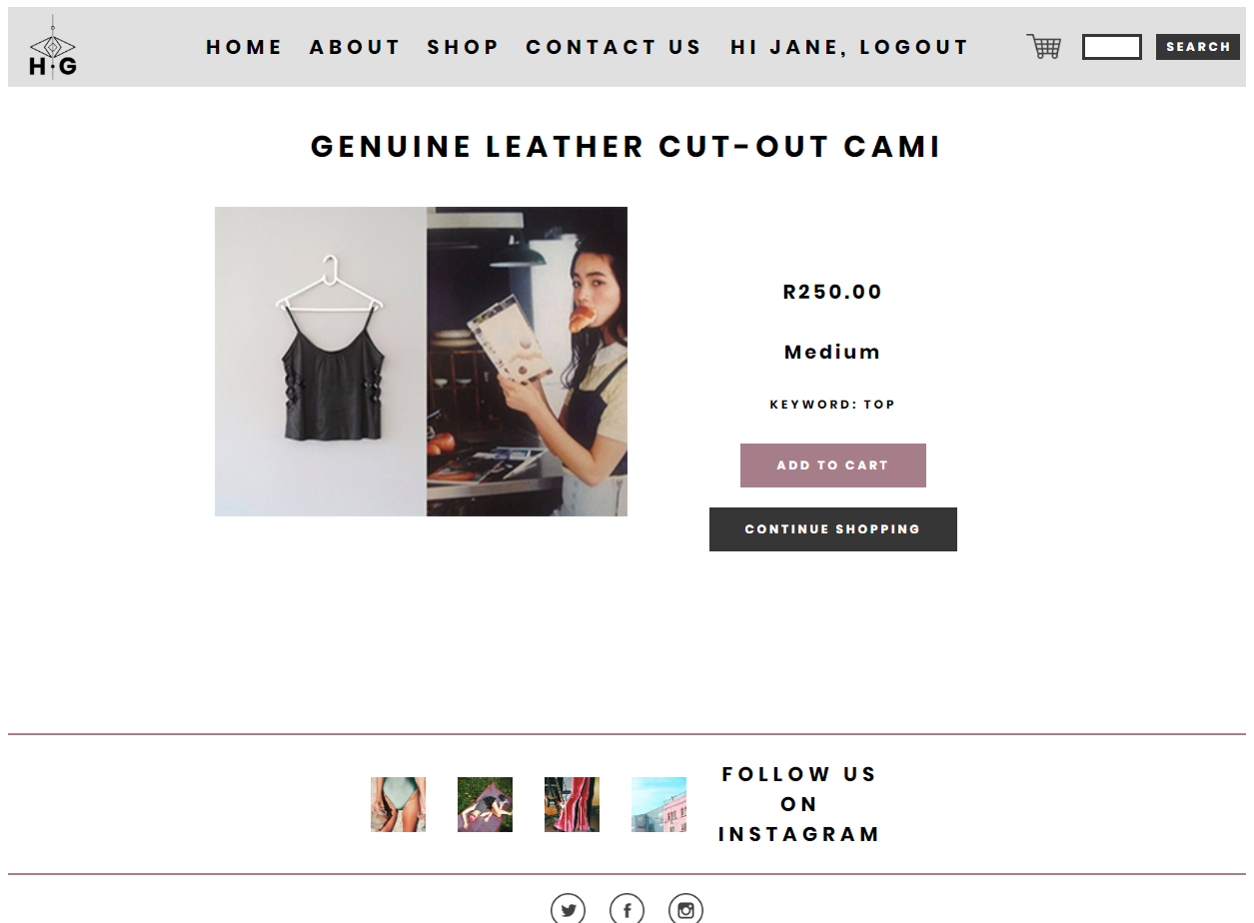

* 1. How to remove a product from the shopping cart
     1. Navigate to the LOG IN / REGISTER page



* + 1. Login with customer account



* + 1. Select cart icon



* + 1. Scroll to product and select X

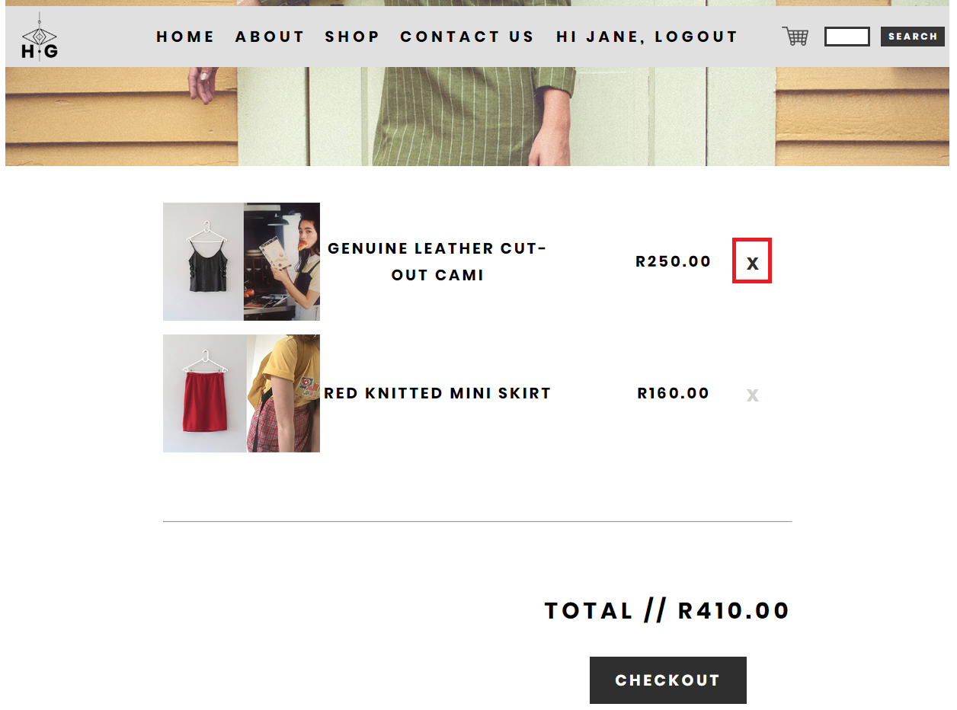

* 1. How to pay for a shopping cart
     1. Navigate to the LOG IN / REGISTER page



* + 1. Login with customer account



* + 1. Select cart icon



* + 1. Select CHECKOUT

